Multifunctional low-cost Optomechanical devices

PH4051D, Project: Part 1 Report

Submitted in partial fulfillment of the requirements for the award of the degree of

Bachelor of Technology

in

Engineering Physics

by

Suryasaradhi B (Roll No.: B180976EP)

Alex Shajan (Roll No.: B180649EP)

Under the guidance of

Dr. Subramanyan Namboodiri Varanakkottu



Department of Physics

NATIONAL INSTITUTE OF TECHNOLOGY CALICUT

NIT Campus P.O., Kozhikode - 673601, Kerala, India
December 2021


CERTIFICATE

This is to certify that the report entitled “Multifunctional low-cost Optomechanical devices” is a bonafide record of the PH4051D, Project: Part 1 done by Suryasaradhi B (Roll No.: B180976EP) and Alex Shajan (Roll No.: B180649EP) under my supervision and guidance, in partial fulfillment of the requirements for the award of the degree of Bachelor of Technology in Engineering Physics from National Institute of Technology Calicut. The contents of this report, in full or in parts, have not been submitted to this or any other institution or university for the award of any degree or diploma.

Dr. Subramanyan Namboodiri Varanakkottu (Guide)

Asst. Professor

Dept. of Physics

Dr. Aji A Anappara
Associate Professor & Head
Dept. of Physics
Place : NIT Calicut
Date : 30 November 2021

DECLARATION

We declare that this project report titled Multifunctional low-cost Optomechanical devices submitted in partial fulfillment of the degree of Bachelor of Technology in Engineering Physics is a record of original work carried out by us under the supervision of Dr. Subramanyan Namboodiri Varanakkottu, and has not formed the basis for the award of any degree or diploma, in this or any other institution or university. In keeping with the ethical practice in reporting scientific information, due acknowledgements have been made wherever the findings of others have been cited.

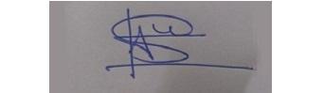

Alex Shajan

B180649EP

Signature

Suryasaradhi B

B180976EP

Place : NIT Calicut
Date : 15 November 2021

ACKNOWLEDGEMENT

We would like to express our sincere thanks to Dr Subramanyan Namboodiri Varanakkottu for his valuable guidance and support in doing our project.
We would also like to express my gratitude towards our head of department Dr Aji A Anappara and Faculty advisor Dr Aswathy G for giving us this great opportunity to do a project on the topic Multifunctional low-cost Optomechanical devices. We would also like to use this opportunity to thank the members and research scholars in the Optics laboratory. Without their support and suggestions, this project would not have been completed.
Suryasaradhi B
Alex Shajan

ABSTRACT

Optical modulators/beam choppers are inevitable part of optical circuits. Existing technologies rely mainly on mechanical and electro-optic modulators, which are bulky and expensive. The proposal aims to fabricate multifunctional optical devices (modulator with beam steering) that can be completely remote controlled, readily integratable and scalable; at a lower cost than its market counterparts.

Our Innovation is a system consisting of a diaphragm who’s on-top a blockhead is mounted to, the diaphragm oscillates at a frequency which is up to 10khz in our product design specification, the oscillating diaphragm causes the attached blockhead to oscillate. When a laser is passed between the path of oscillation it gets chopped by the blockhead, this setup is the beam chopper. The laser coming out from the chopper hits two mirrors aligned 45 degrees to each other in perpendicular planes, these mirrors are capable of rotating is able to scan the laser beam reflected off of them onto a screen, this part is the Beam Steerer. Hence our product is a combination of both these systems integrated as one unit.

The modern design techniques used for the creation of the optical devices will perform better than the outdated designs in the market, while delivering more features. These devices will be made fully integratable into existing projects by adding an IoT base and incorporating research oriented softwares like LabVIEW into its core designs, thus further adding to its scalability.

CONTENTS

List of Abbreviations ii
List of Symbols iii
List of Figures iv
1 Introduction 1
1.1 Introduction 1
2 Introduction 1
2.1 Beam chopper 3
2.2 Beam Steering 4
3 Electronics Theory 6
3.1 Atmega328p 6
3.2 UART communications 6
3.3 I2C communications 7
3.4 PLL Source Follower 8
3.5 PID Control Loop 9
3.6 Variable Frequency PWM 9
3.7 IOT 10
4 Technologies used in Design 11
4.1 Design
5 Hardware Technology
6 Software
5 Results and Discussion 15
5.1 Results 15
5.2 Analysis 16
6 Conclusions and Scope for Future Work 21
6.1 Conclusions 21
6.2 Scope for Future work 21
LIST OF ABBREVIATIONS

IOT Internet of Things
LDO Low-Dropout Regulator
MCU Microcontrollers
ML Machine Learning
OP AMP Operational Amplifier
PID Proportional Integral Derivative
PWM Pulse-width Modulation

LIST OF SYMBOLS

 Electrical resistance (ohm)
V Voltage
q Charge of an electron (1.6 × 10⁻¹⁹ C)
t Time (s)
I_{o} Output current (A)
K Boltzmann constant (1.38 × 10⁻²³ J/K)
T Absolute temperature (K)
V_{o} Output voltage (V)

LIST OF FIGURES

1.1 Design of Beam Chopper 3
1.2 Design of Beam Steerer 3
2.1 Atmega328p microcontroller 5
2.2 A Block Diagram of UART Communication 6
2.3 A Block Diagram of I²C Communication 7
2.4 PLL Control Diagram 7
2.5 A Block Diagram of PID Control loop 8
4.1 Simulation Diagram 15
4.2 Chopper Wheel 17
4.3 Repeatability Test 17
4.4 Linear Chopping Tests 18
4.5 Lens Configuration for Reducing Bream Diameter 19

CHAPTER 1
INTRODUCTION

1.1 INTRODUCTION
Optical devices are all around us, from the zoom lens of a camera to optical instruments in a spacecraft. The knowledge used to develop these systems comes from optomechanics, a combination of optical and mechanical engineering. Opto-mechanical engineers combine optical and mechanical engineering to develop optical systems and devices such as lasers and lenses. Due to their wide range of applications in both the High-Tech industry and day-to-day technology, optical systems often have to meet tight requirements in terms of shape and size while being resistant to all kinds of external loads. This makes the development and production of optical devices a challenge. Optomechanical engineers need to come up with solutions for these challenges, using their knowledge of the physical properties of light in addition to understanding the principles of mechanical engineering.
Optomechanics is a rapidly developing field of research that explores the interaction between light and mechanical motion, with its current experimental focus on micro- and nanoscale systems. The combination of modern nanofabrication techniques for mechanical devices and ultralow dissipation optical cavities has enabled an explosion of experimental progress in the past few years. The principles of optomechanics show promise for both applications and fundamental investigation. Optomechanical systems are advancing the art of precision measurement of small displacements, forces and masses, and all these functionalities are now also available on-chip thanks to novel integrated platforms. Optomechanical systems are now also considered to be prime candidates for realizing quantum interfaces between solid-state qubits and photons, with applications in information storage and processing envisioned.

Currently there is a monopolistic scenario that many corporates have. This has led to high cost of instruments and with effectively no manufacturer of these high precision instruments India adds import tax and other restrictions to these problems. By implementation of new methods, we can make high precision affordable optical instruments in India. We are providing a solution to replace the current expensive and outdated optical instruments used to make optical circuits. The proposal aims to fabricate optical devices that can be completely remote controlled, readily integratable, scalable to the projects; at cheaper rates than its market counterparts. The modern design techniques used for the creation of the optical devices will perform better than the outdated designs in the market, while delivering more features. These devices will be made fully integratable into existing projects by adding an IoT base and incorporating research software like LabVIEW into its core designs, thus further adding to its scalability.

CHAPTER 2
OPTICAL DEVICES
2.1 Beam-Chopper
An optical chopper is a device which periodically interrupts a light beam. There are conventionally three types of models available: variable frequency rotating disc choppers, fixed frequency tuning fork choppers, and optical shutters. A rotating disc chopper is the most commonly used Beam-Chopper and was famously used in the first non-astronomical measurement of the speed of light.
Optical choppers, usually rotating disc mechanical shutters, are widely used in science labs in combination with lock-in amplifiers. The chopper is used to modulate the intensity of a light beam, and a lock-in amplifier is used to improve the signal-to-noise ratio. To be effective, an optical chopper should have a stable rotating speed. In cases where the 1/f noise is the main problem, one would like to select the maximum chopping frequency possible. This is limited by the motor speed and the number of slots in the rotating disc, which is in turn limited by the disc radius and the beam diameter.
Here, we would like to replace the conventional disc beam chopper with a newly fabricated diaphragm-based model which uses the up and down motion of a specially fabricated, highly precise material and cuts the beam at required frequency.
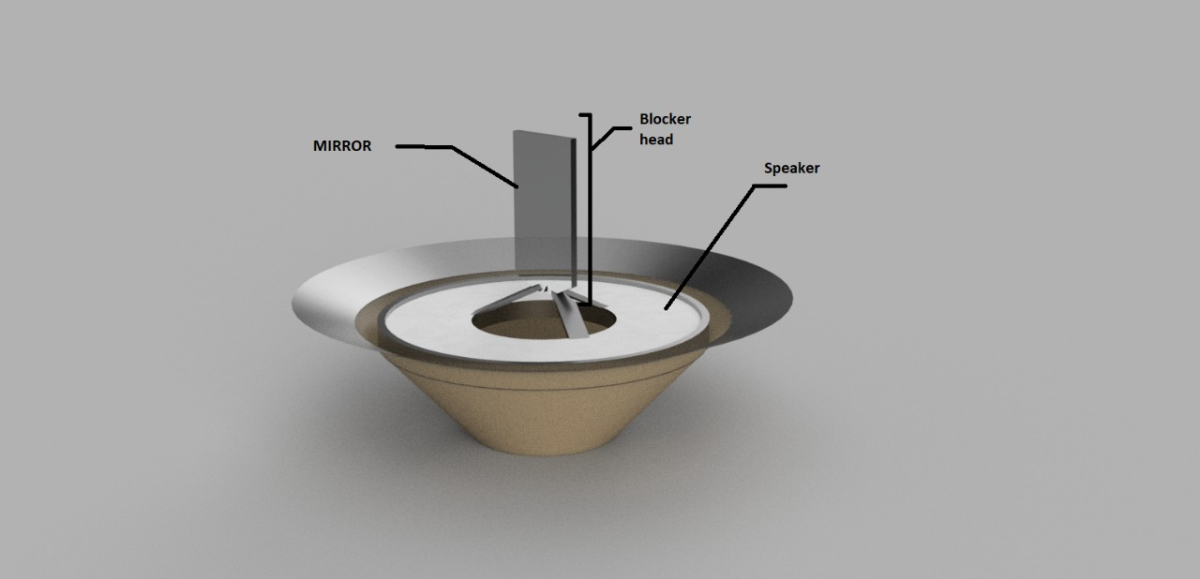
Fig 1.1

2.2 Beam Steering
Beam steering is about changing the direction of the laser beam and projecting it on a desired point in the screen. The configuration contains 2 mirrors facing each other at 45º, both of which are connected to steppers who make them rotate in perpendicular planes. Therefore, the lower motor deals with scanning in the X axis, while the upper one scans in the Y axis. The model is fabricated using high end 3-d printers for printing the base and delicate materials up to nm range precision.
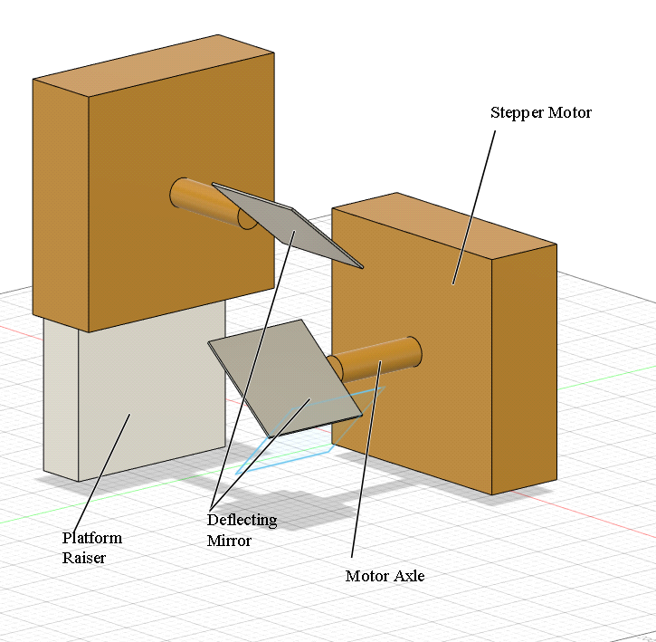
Fig 1.2

X-Y Beam Steerer made would used two NEEMA steppers at 45degree to each other controlled precisely by the stm32 running at 100mhz, with a precision of ~500millidegree, Cheap versions which require less micro precision will be made using Tower pro steppers. These steppers compromises speed for accuracy. For non-fast but precise applications, use of servos is preferable because tower pro servos have precision in the degree range compromising for speed of movement. The Steppers will be in-sync with each other through a feedback where a hall effect probe will stick out of one of the shafts of the motor. A magnetic field is introduced to the hall effect sensor at a distance. The strength of the field determines the position of the mirror at a given point and this feedback mechanism is added as a prevention to common step skips in stepper motors where certain steps are skipped by steppers due to the formation of internal eddy currents. This will determine the precise tilt of the mirror. This data will be coupled with a PID loop (feedback controlled) to damp the stepper motors damp inherent inertia hence achieving precise control of the mirrors.

CHAPTER 3
ELECTRONICS

3.1 Atmega328p
Atmega328p is the brain of the electronic circuit. It is manufactured by Atmel as part of the mega series. 32 in the represents its flash memory capacity of 32kb and 8 represents the 8-bit CPU type. So, Atmega328p is a high performance yet low power consumption 8-bit CMOS microcontroller IC with reduced instruction set computer architecture with 32*8 general purpose registers and 131 instructions. Atmega328p consumes less power as compared to its predecessors. Arduino is one of the several IDEs used to control it. It operates in the voltage range 1.8V to 5.5V. They are simple to readily usable without additional computing components with 32k bytes of onboard self-programmable flash program memory as well as 23 programmable I/O lines. All 31 registers are directly connected to the Arithmetic Logic Unit which makes it faster than the conventional CISC microcontrollers.
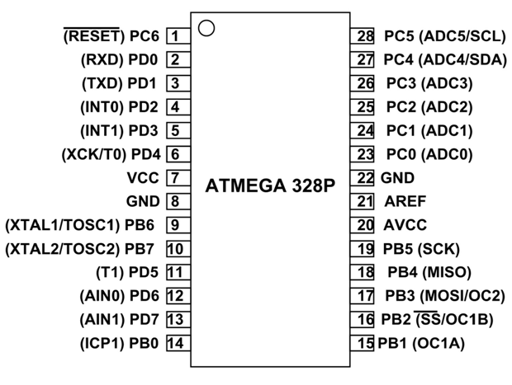
Fig 2.1

3.2 UART Communication
Communication protocol plays a big role in organizing communication between the devices. UART is used by the microcontroller to communicate with the various sensors in the device. UART or universal asynchronous receiver-transmitter is one of the most used device to device communication protocols. Here, 2 UARTs communicate directly with each other. UART can work with many different types components that involve transmitting and receiving serial data. In serial communication, data is transferred bit by bit using a single line or wire. Depending on the application and system requirements, serial communications need less circuitry and wires which reduce the cost of implementation.
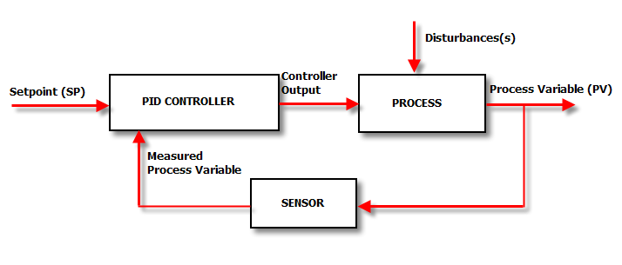
Fig 2.2
UARTs transmit data asynchronously. There is no clock signal to synchronize the output bits from transmitting UART to the sampling of bits by receiving UART. The transmitting UART adds start and stop bits to the data packet being transferred since clock signal is absent. The start and stop its define the beginning and end of the data packet so the receiving UART can understand.

3.3 I²C Communication
I²C also known as IIC stands for Inter-Integrated circuit. It is a bus interface connection protocol incorporated into devices for serial communication. It is a widely used protocol for short-distance communication and is also known as Two Wired Interface.
I²c uses 2 bi-directional open drain lines for data communication- Serial data (SDA) and serial Clock (SCL). I²c has various benefits compared to other communication protocol. It can be configured in multi-master mode. Unlike SPI communication, complexity is reduced because it uses only 2 bi-directional lines. It is also very cost-efficient. Lack of speed counts to its disadvantage.
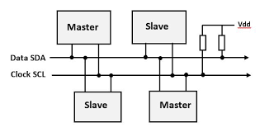
Fig 2.3

3.4 PLL Source Follower
By using a PLL or Phase locked Loop, a custom source can be fed in and can be made to follow, unlike any other configuration which assumes signal reflectance at contact, a PLL based signal follower is capable of locking onto the source and following it, if the source frequency is within the PLL’s Locking frequency the PLL locks the source signals and follows it, furthermore with the use of PLL, the said frequency can be divided into its base frequencies and used. The PLL of choice to be used in the project is CD4046.
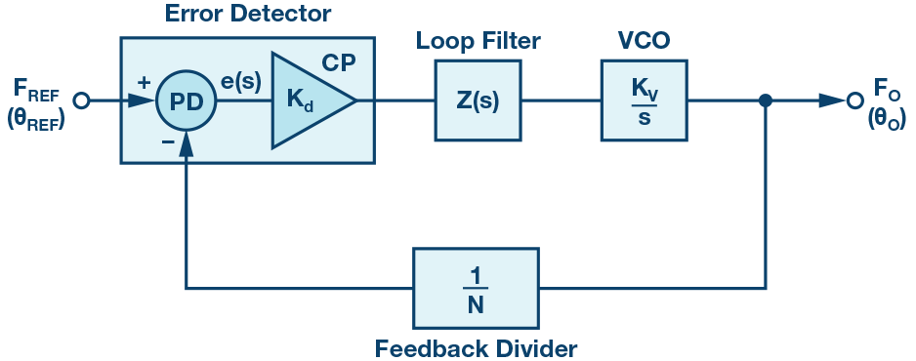
Fig. 2.4

3.5 PID control loop
PID or Proportional Integral Derivative controllers use a control loop feedback mechanism to control process variables and are the most accurate and stable controller. PID is a well-established way of driving a system towards a target position or level. It uses close-loop control feedback to keep the actual output from a process as close to the target or setpoint output as possible. In this project, PID loop is used as feedback to control the components and prevent them from going out of the sync. PID controllers are best used in the systems which have a relatively small mass and those which react quickly to changes in the energy added to the process. It is recommended in systems where the load changes often and the controller is expected to compensate automatically due to frequent changes in setpoint. The working principle behind a PID controller is based on the difference between the values of proportional integral and derivative terms are calculated and applied to the input.
Fig 2.5

3.6 Variable frequency PWM
Variable frequency Pulse Width Modulator or VFPWM is used to control the duty cycle and frequency of the beam chopper. As the name suggests, the width of the pulses of a waveform is controllable.

3.7 Ripple Filter Capacitors
Ripple Filter Capacitors are basically used for stabilizing the power supply.

3.8 IOT
Internet of things or simply IOT is a system of interrelated computing devices or objects that are given unique IDs and have the ability to transfer data without human interaction. An IOT ecosystem consists of smart devices which use embedded systems to collect send and act on the data that they acquire from their environments. These devices do most of the work themselves without any human intervention. IOT uses Artificial Intelligence and Machine Learning to aid in making data collection process easier and more dynamic.
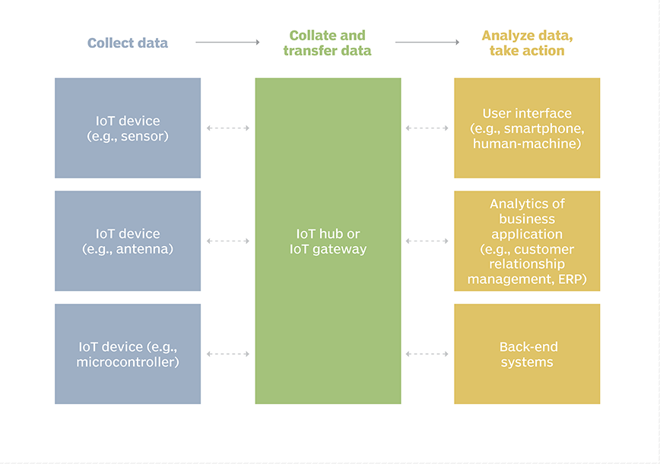
3.9 28BYJ STEPPER
For the first stage 28BYJ stepper motor is used. Stepper motors are used to increase the precision as the motor rotates in steps and angle rotated in each step can be calculated and angle can be rotated accordingly. Servo motors are used when speed is required but for this project, precision matters more than speed.

3.10 NEMA STEPPER MOTOR
Nema stepper motor is used as an advancement to 28BYJ stepper motor. Nema motor have better movement and precision as compared to others. It has low maintenance and will work in any environment and will even operate in an open loop control system.

CHAPTER 4
Technologies Used in Design

4.1 DESIGN

The project consists of both hardware and software stack, the core of the project revolving around its processor Atmega328p and NRF5210. The processor takes care of:
- RF communication
- Serial USB communication
- Power Management
- PWM adjustment
- Clock generation
- Current sensing
- Contact Temperature sensing
- Coil Position Sensing
- PLL Source follower
- Beam Steering with Feedback

As the device is intended for lab use we need a very repeatable instrument, Due to this specification the noise throughput must be the least, Noise in Most systems are generated as a result of variation in the power supply and voltage dependencies of most components with temperature to overcome the concern of fluctuating voltages ,instead of using the microcontrollers internal precision voltage reference we are using an external high precision voltage reference AD584 IC ,which can supply a solid 5V precision to the microcontroller’s AREF pin, even if the supply fluctuates, the MCU (microcontroller) will take comparisons with respect to this voltage on its operations.

RF communication done via a TCP/IP brings this device to the IoT forefront, the device can be operated through 2.5ghz WIFI available in any smart device. The device will feature a responsive UI where you can see Realtime updates of the current state of the system, take readings, perform experiments, save and share results etc. On the smart device you can simply scan the QR code provided with the device to go to a specific link on your devices browser which on opening will feature the UI of the device. This feature is added by simply running an Apache server on the device and handling out http requests on the go. The TCP IP stack is handled by the ESP/NRF5210 IC which has inbuilt WIFI adapters. The estimated range of operation of the device being 20m.

Serial communication can be used as a faster means of debugging if the smart device doesn’t have WIFI provision, having a serial interface is also a universally accepted protocol thus making it compatible with almost all devices without the need of any external drivers. The serial protocol RS232 is supposed to be implemented using a CH340G chip which is a USB to UART converter. Selected baud rate for communication being 115200, as this is a high-speed standard value supported by most devices.

The power supply to the device will be through an SMP providing 12 V @ 10A current, Furthermore the power system will again be managed by two sections in the device, the LDO section and the buck boost section, this is done so as to decrease the 12 V to 5V for the microcontroller and 3.3V for the sensors. The LDO of choice is an LM317 adjustable voltage regulator capable of sourcing 1.5A of current ,adding a NPN transistor to its output pin increases its output current as specified in the datasheet, from this supply the microcontroller and the accessories are powered at 5V, The buck switching section would step down the voltage while retaining high efficiency , this will be applied to directly drive the speakers at 10V ,the chosen hardware for the buck switch being LM3124 capable of sourcing up to 10A of current at 10V, We are not using the 12V as is to drive the speakers as if we regulate or step down a DC voltage to a lower value the chances of reducing supply noise are high thus giving our speakers a better supply voltage, furthermore to stabilize the power supply ,ripple filtering capacitors will be added. A current protection diode, a fuse with a varistor will be added to prevent back-emf from the motors of beam steerer as well as from the woofers, this is of utmost importance to prevent the circuitry from burning up in case of any current spikes.

The Processor will keep in track of the clock, an external 16mhz crystal will be added as the clock generator for the atmega328p while the nrf5210 have an internal oscillator. The clocks for the i2c buses will be provided by the microcontroller as it is the master who manages the SCL line. By manipulating the hardware Timers 1 & 2 of the microcontroller we are able to generate a PWM wave of adjustable duty cycle at variable frequency if the approach seems to bring in errors as microcontrollers may miss some clock pulses or the system was busy doing some other tasks then an external PWM oscillator will be used consisting of a current mode PWM controller UC3843 IC which will do the task of the PWM controlling separately. The PWM signals are fed into the H Bridges enable pin, thus decreasing the total Power output of the speakers, this PWM as a feedback for maintain the chopper working at a fixed power while another set of PWM signals will be fed into the H Bridges gates. This will be used to control the duty cycle of chopping. All the PWM controls will be software handleable, i.e., controllable through WIFI as well as serial and there will be separate potentiometers on the device for controlling the PWM frequency, and duty cycle.

Current Sensing will also be done as a feedback to measure the output power of chopper system, this will be INA219 I2C Interface No Drift Bi-directional Current / Power Supply Monitoring Sensor, from the output of this sensor the MCU will regulate the PWM to provide a constant power output. This can also be used to detect the efficiency of the device over time and tell the consumer to replace parts, if necessary, as usually parts degrade over time and current flowing through them increases as resistance builds upon degrading parts hence this sensor can act as a troubleshooting mechanism too.

A contact temperature sensing option includes attaching an LM35 temperature sensor. This will act in par with the current sensor to monitor the health of the system’s main mechanical part, the choppers and the motors, and report the current temperature of theses devices back to the user through the UI’s

Coil positioning is an important parameter as this will provide the best feedback as to know whether we are getting the frequency we requested for, A PID loop will run in tandem with the coil position sensor adjusting the input frequency until the output matches the desired set point. The coil position sensor will actually be a IR sensor with a photo detector set to measure proximity, by measuring the amplitude of the IR falling on the photodiode the distance from the obstacle is from the photodiode can be calculated although this is not recommended for distance more than 10cm, since in our application the moving parts doesn’t move more than that this is the most suitable candidate for the job.
Another addition to the arsenal of features packed onto the device is a Source follower ,researches can sent their own custom frequency ,within a range of 50mVpp to 5Vpp to be followed by the speaker ,this is done by using a programmable op amp to normalize the amplitude of the input wave then feeding that to a PLL which locks with the input essentially following it, this is then fed through power amplifier consisting of TDA2002 then to the speakers, here the H Bridge is intentionally avoided to make the speaker follow exactly the sources pattern ,whereas in H bridge we can only oscillate using a square wave.

Thus, we have discussed our innovative designs with the beam chopper another component we wish to add is the beam steering which can scan the laser beam to any point on screen, High precision NEEMA steppers will be used to drive the perpendicular mirrors, the MCU will take control of the scan, by feeding in an excel sheet consisting of the angle and step speed, the microcontroller will go through each column and execute those required parameters. Feedback will be made to the stepper consisting of the rotary encoders to ensure that the angles of the steppers were exact as the setpoint or else a PID comes into play correcting the output.

CHAPTER 5
RESULTS AND DISCUSSION

5.1 RESULTS

Tests were conducted to evaluate the performance of the suggested Diaphragm based model. We initially begin with comparing the conventional rotary based chopping to diaphragm based chopping, for these we had to create a 3d rotary wheel with thick spokes on it, using a DC motor and an IR feedback sensor we were able to measure the consistency of the motor in action, this was compared against linear based chopping where a blockhead situated above the speaker chopped the laser beam at periodic intervals. A graph was plotted showing how inconsistent the results were as showcased by the DC motor. While consistent results were observed for Linear Chopping.

A basic setup of how the device should be working was made as a 3d diagram in fusion360 with this as reference for placement of parts housings for the hardware were made. Most of the components necessary for prototyping had been procured and quality tested. Simulations for the circuits were created in proteus for measuring the current requirement, power output of the device, for determining the minimum voltage requirement and total runtime on various stored power supplies. Double sided PCB layouts and 3d Figures of the PCB layout were created for the same. For LabVIEW and COMSOL integration Serial Communication was setup as the medium of information exchange, this further needs to be tested to verify whether a separate device driver needs to be written or not. Serial communication was chosen as it was universal and most PC’s (both nix and windows) could interact with serial without the any compatibility issues.
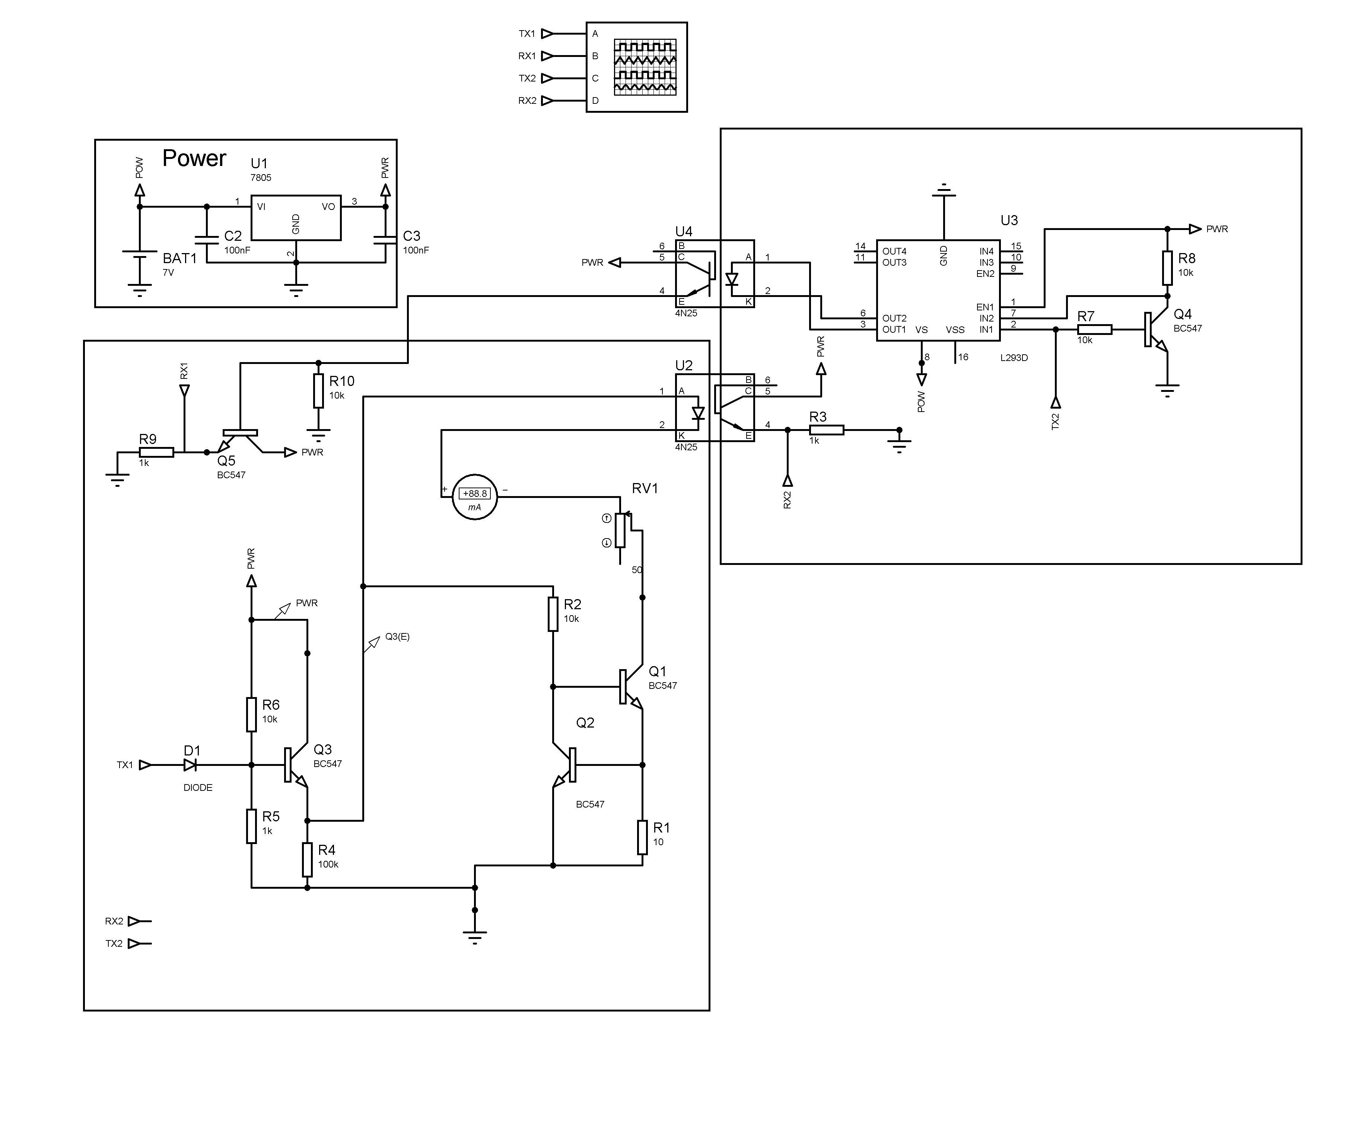
Fig 4.1
The beam steerer part of the design was made on concept with the standard devices available in the market where two mirrors arranged in perpendicular planes oscillated with respect to each other to scan the beam through the wall.

5.2 ANALYSIS

The system under study consisted of two major parts The beam chopper and the beam steerer. This system was integrated into one unit for ease of access. For testing these two devices extensive study was done. One such include how much current would the device draw and how much power would it consume. This played a crucial role in designing a power supply for the system, The estimate of the said parameters were calculated using simulation of the circuits in proteus. By summing up the current consumption of the internal circuitry:

- Motor Driver: 350mA
- Motors: 3A * 2 = 6A
- Processor & Logic: 100mA
- Sensors: 100mA

As the system demanded a high current around 10A at low voltages a conventional 5A 12V SMP, Furthermore an SMP was chosen due to its form factor being small instead of a transformer which would not able to provide enough current even for its big size. The system will run on a battery when the SMP is not available for power, the battery of choice is a 12 V LIPO battery chosen due to its high current throughput.

A comparison study was done for linear chopping and the rotary based chopping using a simple DC motor, DC motors inherently are not a repeatable device, they are affected by noise heavily and even a slight perturbation can cause the output to go disordered. The repeatability of a DC motor was tested by attaching its rotor to a spoked wheel, passing Infrared through one end and recording the output from the other end using a photodiode, this data was carried over to PC over serial and plotted in python. The motor was driven using an H-bridge,
The H-bridge being driven using a periodic square wave. After this a plot of rpm measured using the count registered by the photodiode vs time was plotted.
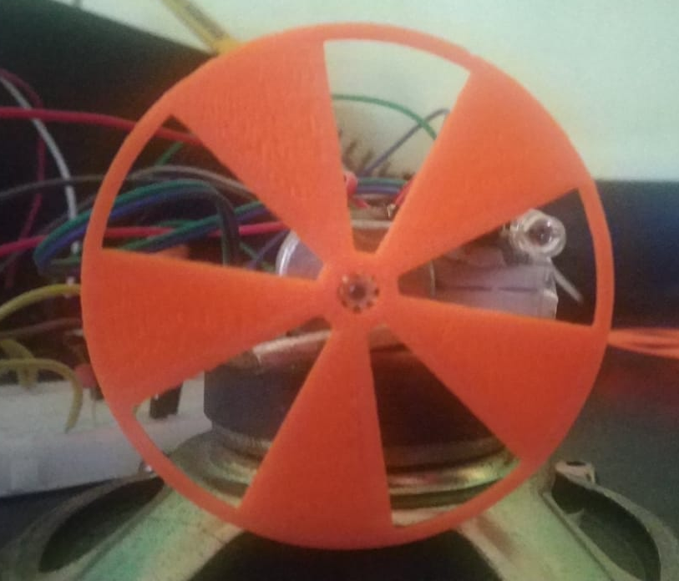
Fig 4.2
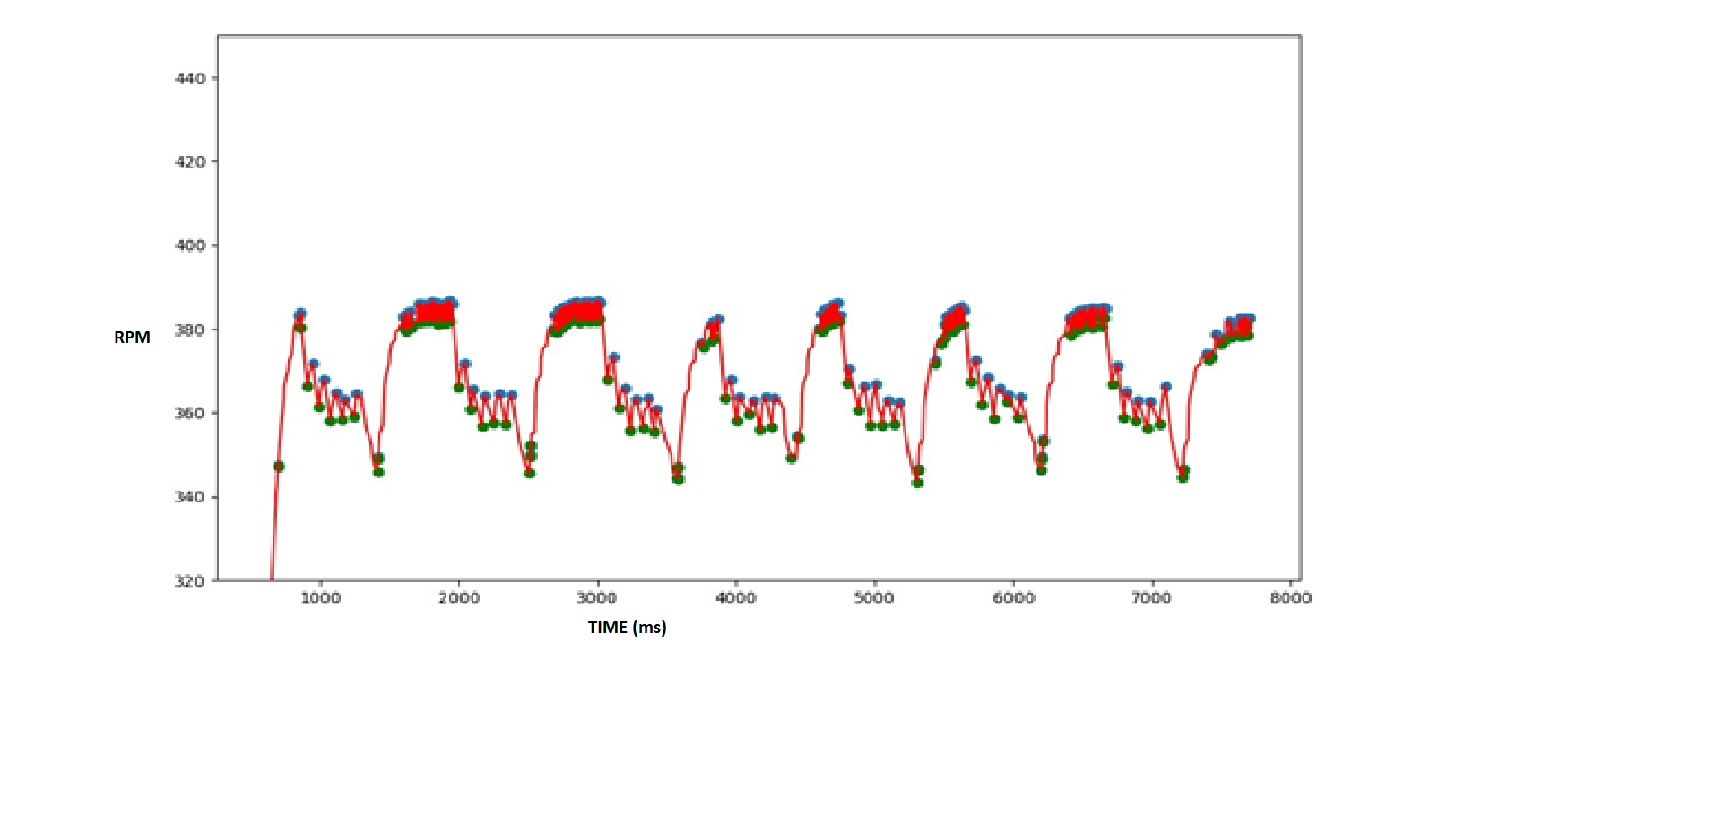
Fig 4.3
Here you can see that the repeatability is an issue since a constant frequency was not even giving consistent results whereas for linear chopping, we were even able to attain communication using laser beams chopped over a distance of 1m over serial.

The linear chopper consists of a woofer consisting of a blockhead on top driven using the square waves of reverse polarity using an H bridge this is done so that the woofer is pulled back unlike it would work in a normal operation where tension pulls it back to its normal position this increases the frequency capability of the system. The main advantage of this linear based chopping is its PWM capabilities, no lower limit to frequency since there are no rotary motion it doesn’t have a minimum start voltage or a minimum rpm and since the device is linear it won’t consume current when it is on its low state thus reducing power usage too. The PWM capabilities expand to controlling the duty cycle of the pulse which was not possible using rotary based chopping this is achieved by using a microcontroller keeping track of time and switching the h-bridge based on the set duty cycle.

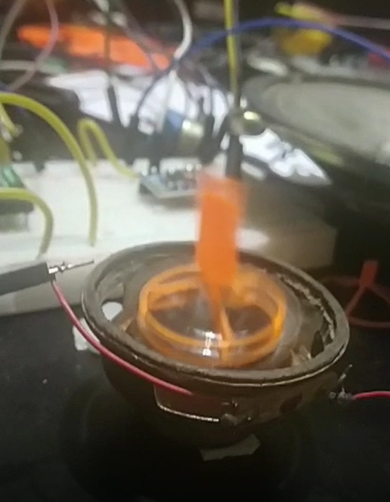
Fig 4.4

Although this linear chopping gives consistent results there are few limitations on using this technology like Frequency response of a coil is narrow, the mechanical amplitude decreases as the frequency increases thus the chopping width decreases at higher frequencies thus only very small laser beams can be chopped at higher frequencies this can be corrected by using a lens focusing system such that the beam diameter at the chopping point is the minimum and another system which would reside after the chopper which would turn back the beam to its initial diameter.

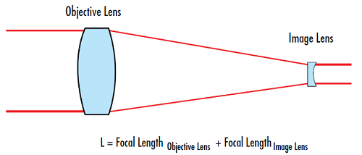
Fig 4.5

Although this mechanism does alter the beam this is the most efficient way to tackle the problem another approach, we could take is by using a rectangle coil on a magnetic field itself as the chopper. This would reduce the weight on the coil and would also eliminate the tension applied by the woofer strings.
CHAPTER 6
CONCLUSION AND SCOPE FOR FUTURE WORK

6.1 CONCLUSION

We will be able to deliver a revolutionary new product to the field jam packed with new features and innovations., Then end product will be an integrated system consisting of a beam chopper and a beam steerer which could be would be provided with IoT base, drivers for LabVIEW, COMSOL support. The product would be extensively tested to meet with accurate repeatability and credibility of operations. Projected beam chopping rate is 10khz and a minimum chopping width of 3mm, the beam steering maximum horizontal scan angle being 75degrees, vertical being 80 degrees.

6.2 SCOPE FOR FUTURE WORK

Although the simulations are finished, the hardware hasn’t started yet, The PCB layout with its grebber files will be sent out for fabrication, Housings will be made in 3d printers and assembled. Software drivers for LabVIEW and COMSOL needs to be written. The actual circuit needs to be made in hardware and checked for errors.

IOSCRIPT Script
Atmega328p acts as the brain of the device. It has a flash memory capacity of 32kb. All Global variables, local variables, boot loader, EEPROM static variables etc. is to be loaded and flashed into the Atmega328p. The basic programming language used for coding is C++. It is a powerful general purpose programming language. It is an Object-oriented programming language which means the language revolves around creating and using objects and class. C++ also has a lot of mathematical functions inbuilt which eases calculations and makes C++ a lot advanced. This makes C++ a programming language oriented towards systems programming and software infrastructure.
Although C++ is an ideal programming language, the use of various classes, objects and functions consumes a lot of memory. Inbuilt header files and advanced mathematical functions makes programming a lot easier but such advanced functions take up a lot of memory and is of very less to no use for this project. Although Atmega328p has a flash memory of 32kb, C++ programming consumes almost all of the memory of the IC. So to overcome this problem, we have developed a new Scripting Language, IOSCRIPT which consumes a lot less memory as compared to C++ programming language. IOSCRIPT is a subset of C++ programming language with removed features like objects and classes. Advanced inbuilt functions are also removed which significantly reduces the size. This makes IOBEAM a simple programming language with basic functions.
var i = 10
ang_type Deg
ang 30d,30d Wait
delay 1000
ask_press

The above code is a sample IOSCRIPT code which sets angle 30 degrees and asks input from the user to terminate. IOSCRIPT has all the basic features like variable initialization, declaration delay etc.. and new added keywords and basic inbuilt functions.

The complete implementation of the code is not ready. An Abstract Syntax Tree (AST) is designed. It represents the syntax of IOBEAM as a hierarchical tree-like structure and is used for generating symbol tables for compilers and later code generations.

A coding terminal IDE is implemented on the IOBEAM website hosted in Heroku. The script first gets compiled by the interpreter and gets send using the ESP826 wifi module. ESP826 wifi microchip do not have the required facility process the code send so it passes serially to the atmega328p which processes the code and sends it to the mirror knob which moves accordingly.
IOBEAM WEBSITE

We have developed and written our IOBEAM website in Django. Furthermore we have also used Javascript and CSS to make the website look clean and user friendly. We have hosted the website in Heroku (https://projectiobeam.herokuapp.com/). Although IOT linking of the website and the device is not completed, all website functionalities have been completed. The website communicates with the device using ESP826 wifi microchip. The website sends data through wifi to ESP826 which in turn communicates serially with the atmega328p IC which controls the motor of the beam steerer and sets the required angle.

REGISTER USER

As usual, the website starts with a register user page which helps the user to create account and access the device. Basic information like Name, Email ID and password is asked for creating the user account. Forgot password option is also available incase the user forgets his user credentials. The data gets stored in Sqlite3 DBMS and is retrieved as needed by the website.
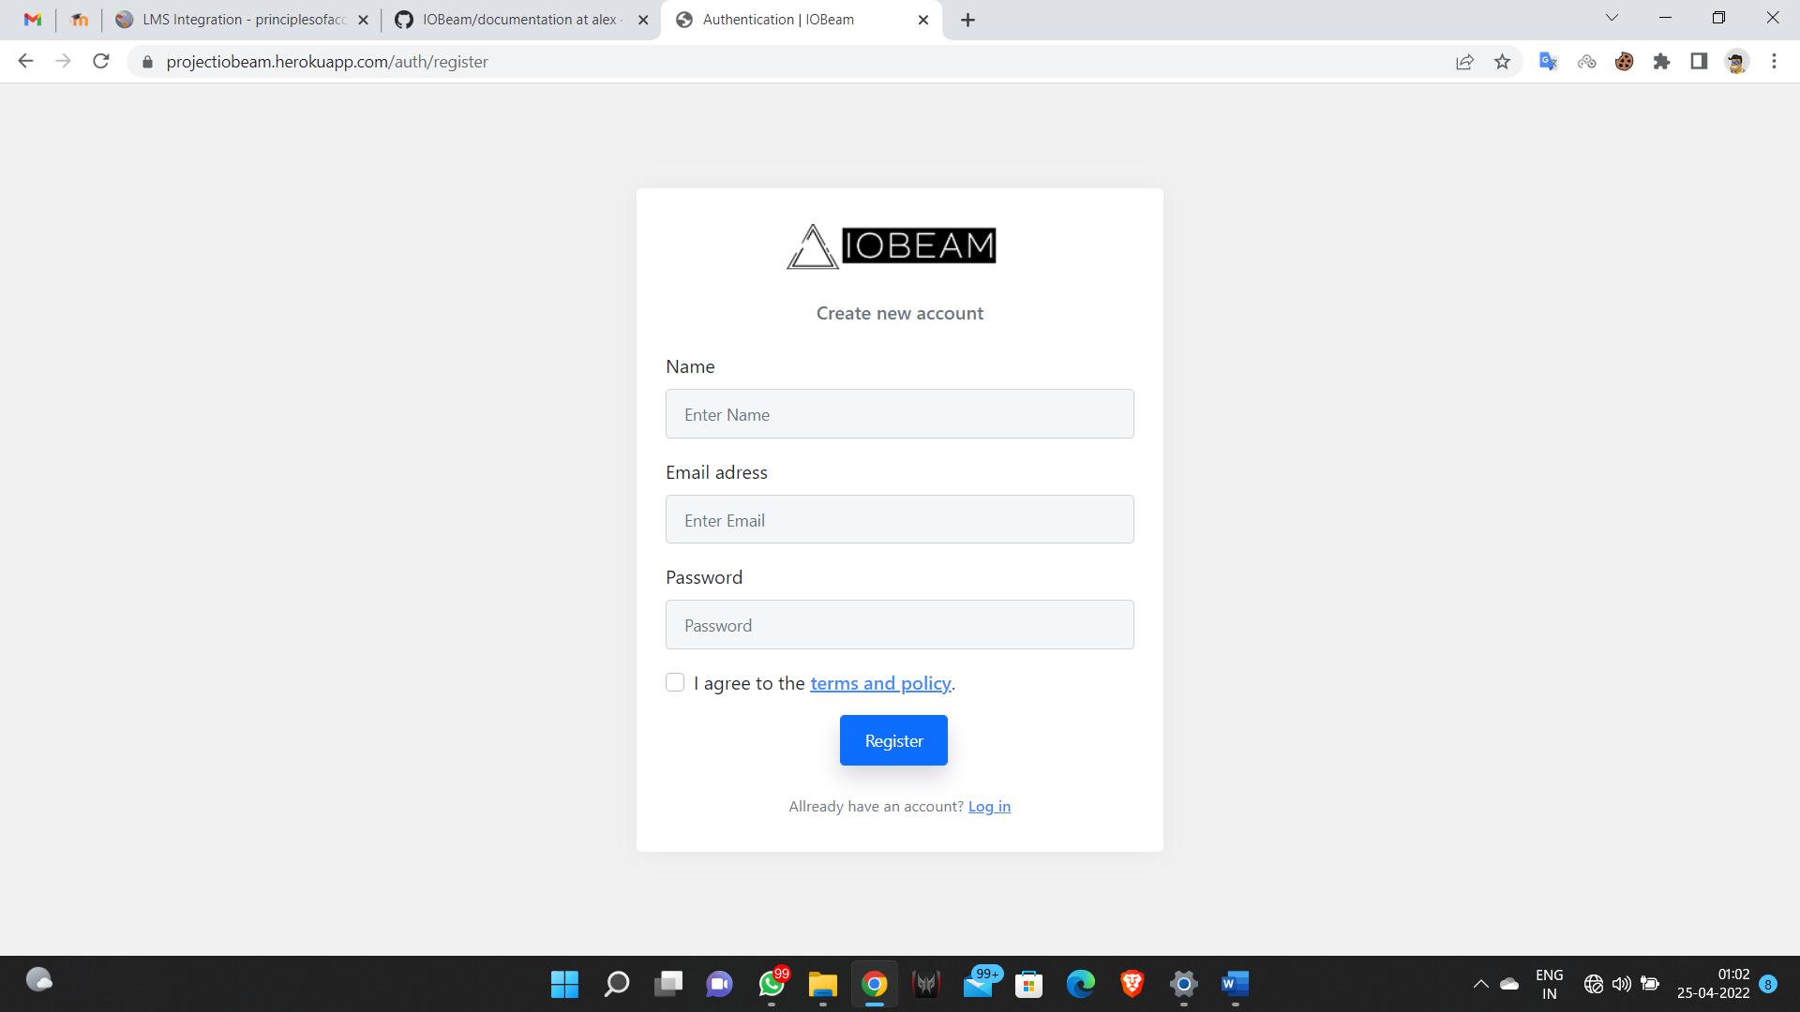

DASHBOARD

The dashboard lists all the registered devices. The navigation to selected devices also takes place from this page. Device name, Unique ID, version and connection status is also listed in this page. Option to delete linked device is also provided in this dashboard.

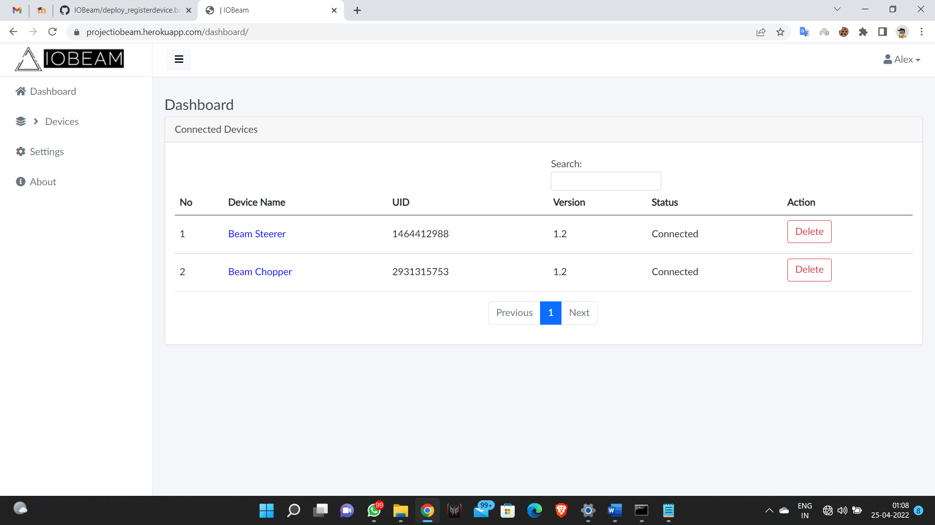
BEAM STEERER

Beam steerer UI helps the user to control the registered device. Reflector 1 and Reflector 2 denotes the 2 mirrors in the device which helps in steering the laser beam to a required point. This page also helps to add, save and run desired scripts by the user.

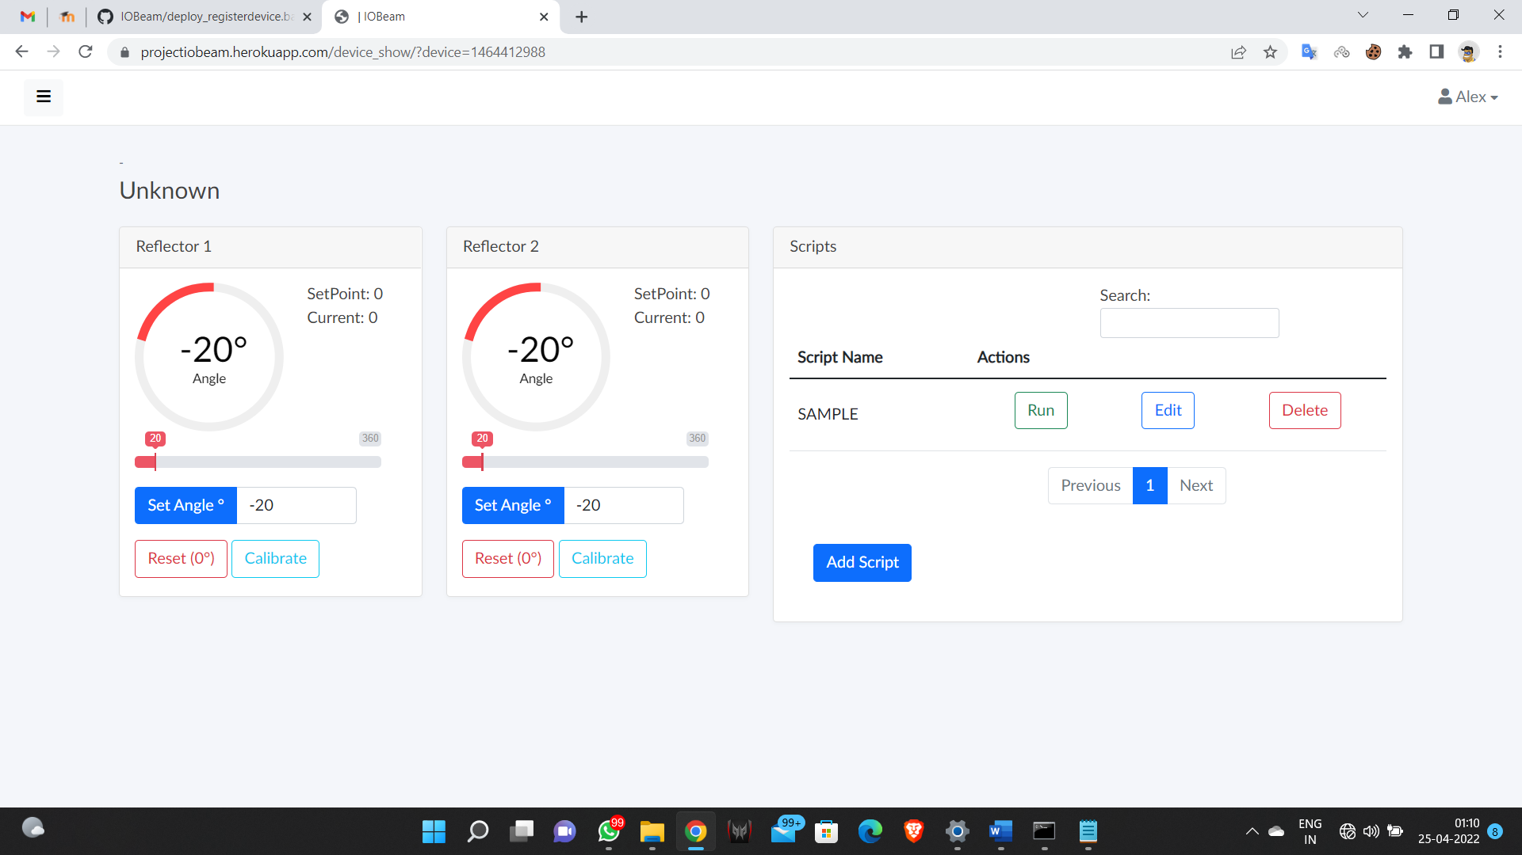

SCRIPTING IDE

The window below denotes the Scripting IDE. We have used DJANGO ACE plugin to develop the IDE. The IDE only accepts IOSCRIPT which is a specially designed scripting language which we developed for this particular purpose. It is an easy-to-use scripting language with new essential keywords for simpler use. Facility to compile and running the code is also provided along with it. The saved code is send to the backend which is then send to the device using ESP826 wifi microchip.

